**Name –** Akash Yashwant Dighe

**Roll No. –** 22

**Subject –** Artificial Intelligence (Practical Output)

**Batch –** Batch B

1. Breath First Search Traversal –

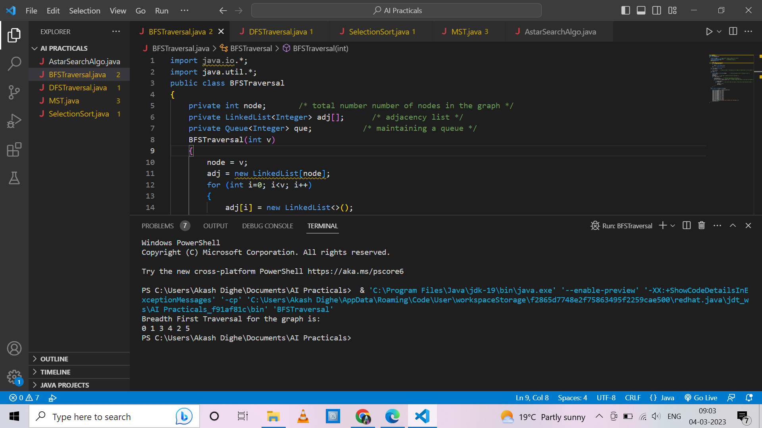

1. Depth First Search Traversal -

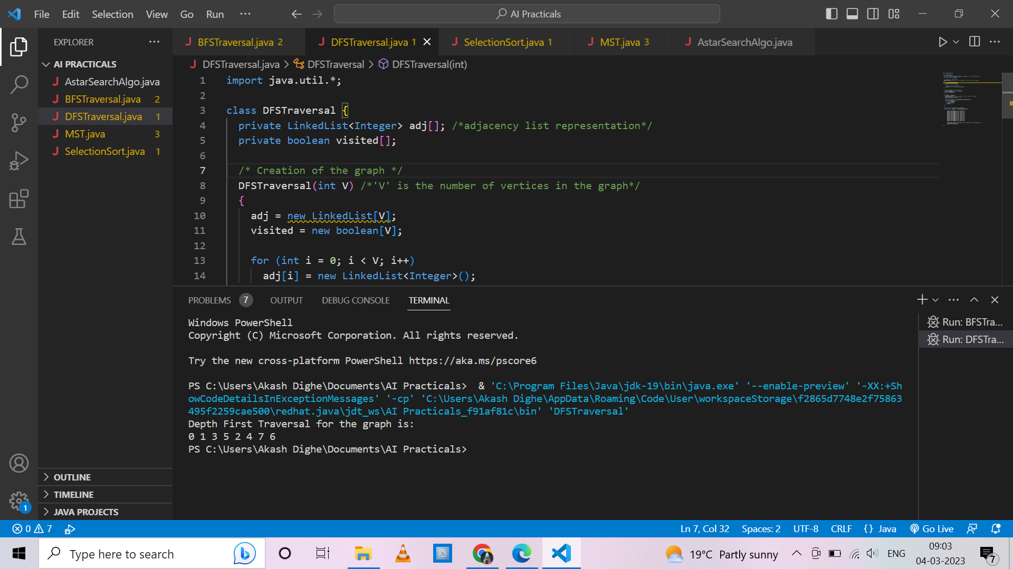

1. Selection Sort Algorithm –

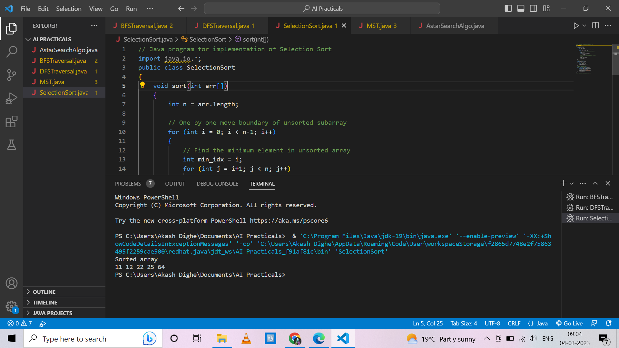

1. Minimum Spanning Tree –

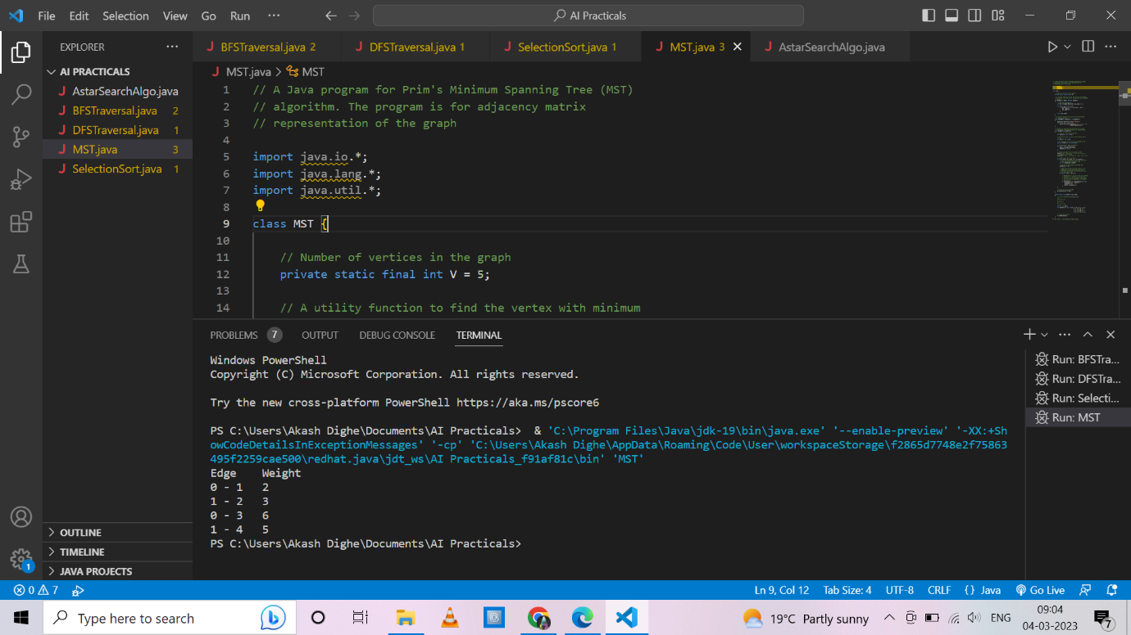

1. A Star Algorithm –

